Developing a vision for our learners

Considering this resource:
Some schools have been using Susan Drake’s model as a framework for developing a learner profile, or as expressed in NZC, the vision (“what we want for our young people” refer p9 and p39 NZC under Achievement Objectives) .
This tool should be used in such a way that ensures all voices (community, teachers, and students) have been heard in the development of the vision and that the vision is inclusive of all students (p9 NZC Inclusion).
The following steps are one way that this tool could be used to achieve this outcome.
Consider sharing the big picture of Drake’s concept of being, knowing and doing and what it means for the different members of our community.
Step 1
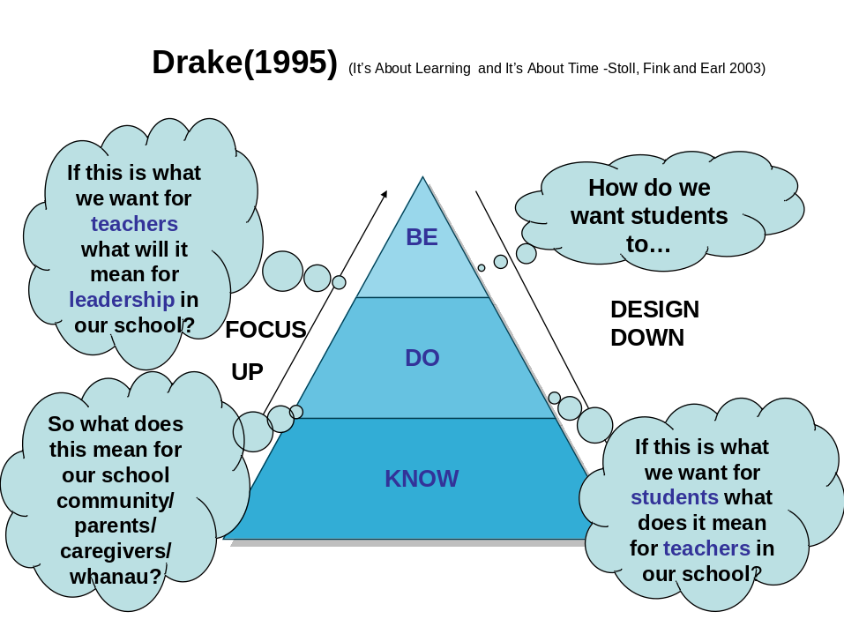
You could work through an example, such as, if we wanted our students to be critical thinkers, what might that mean for the teachers and their practice; what might that mean for leadership (how we might prioritise professional learning for example) and what might that mean for our school community.

Step 2
Think about the all students in our school – the diversity of identities, language backgrounds, abilities and talents. How is this diversity recognized and affirmed in our aspirations?
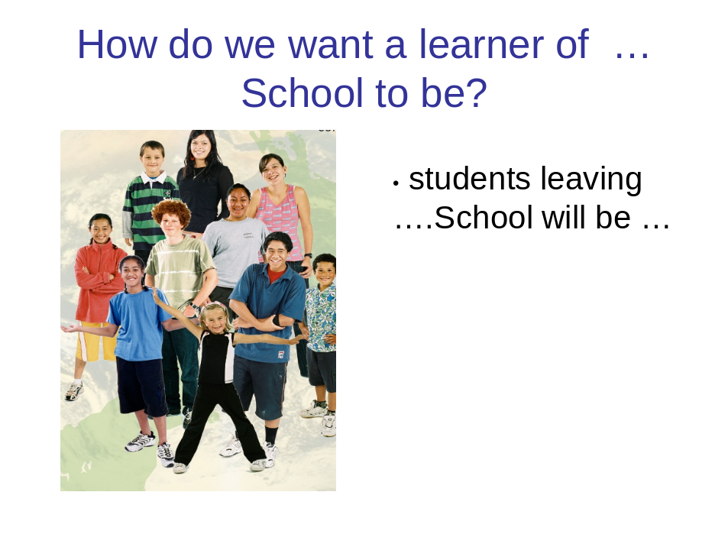
Step 3
The following two tasks might assist in developing this vision.
- In groups, brainstorm what qualities, attributes, attitudes, dispositions …. your learner will have.
- Now select 2 or 3 of those qualities and develop a rich description of what that looks like for this school

The collated material from this process (teacher, community and student voice) can be presented in a number of ways. For example, some schools have aligned their descriptions with the descriptors in NZC. Some have developed a visual metaphor to capture their vision.

From Merle Ramsay, School Support Services, Waikato

